Name : مازن زياد طه

* XOR using NAND only :

* XOR using NOR only :

* X . 0 = 0

* X . 1 = X

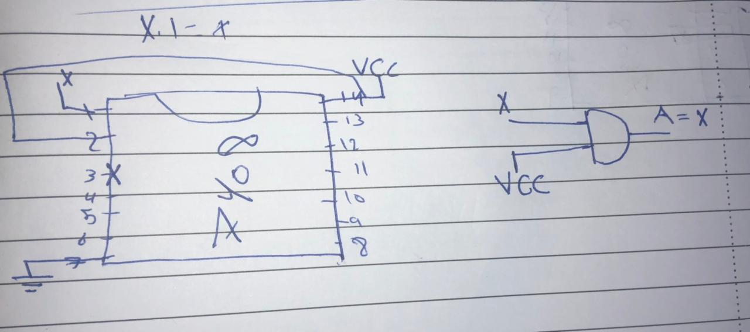

* X . X = X

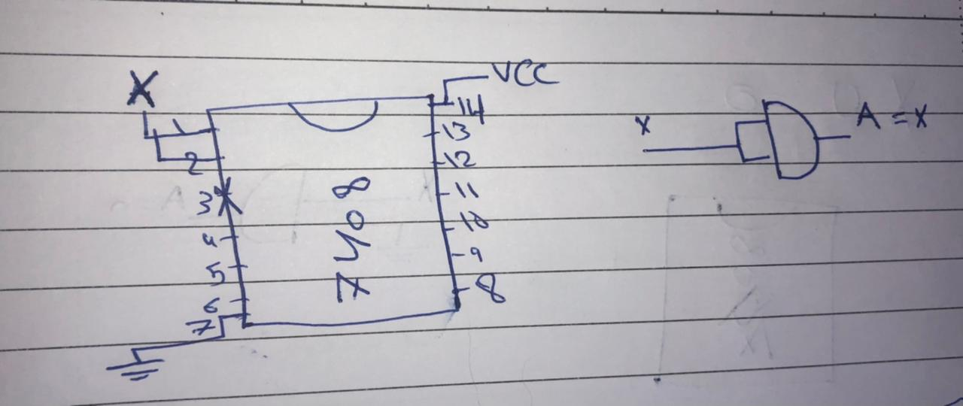

* X . X’ = 0

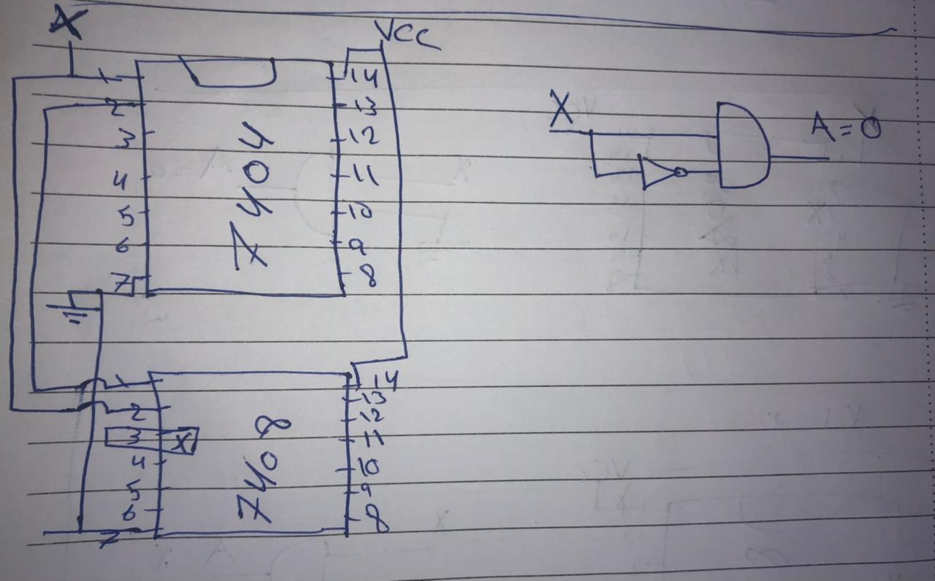

* X + 1 = 1

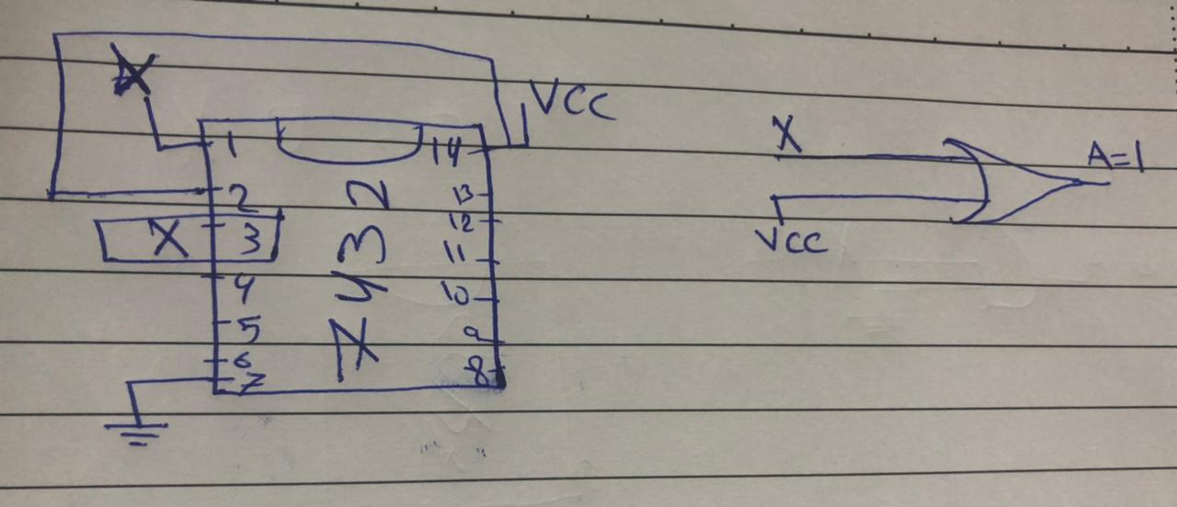

* X + 0 = X

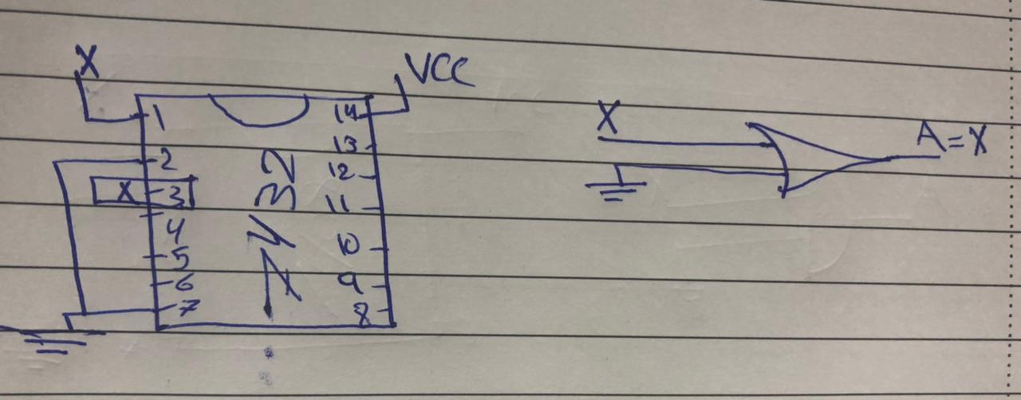

* X + X = X

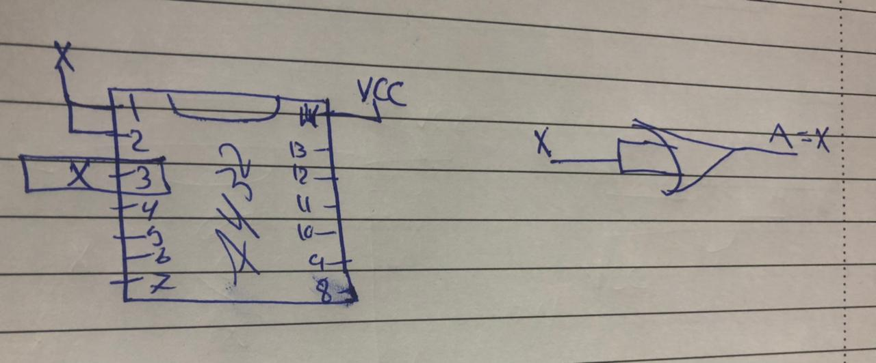

* X + X’ = 1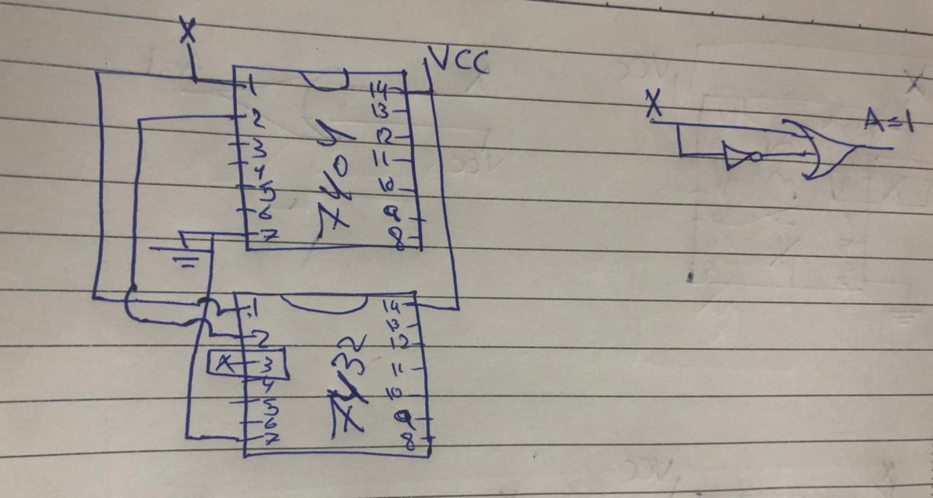
* X’’ = X

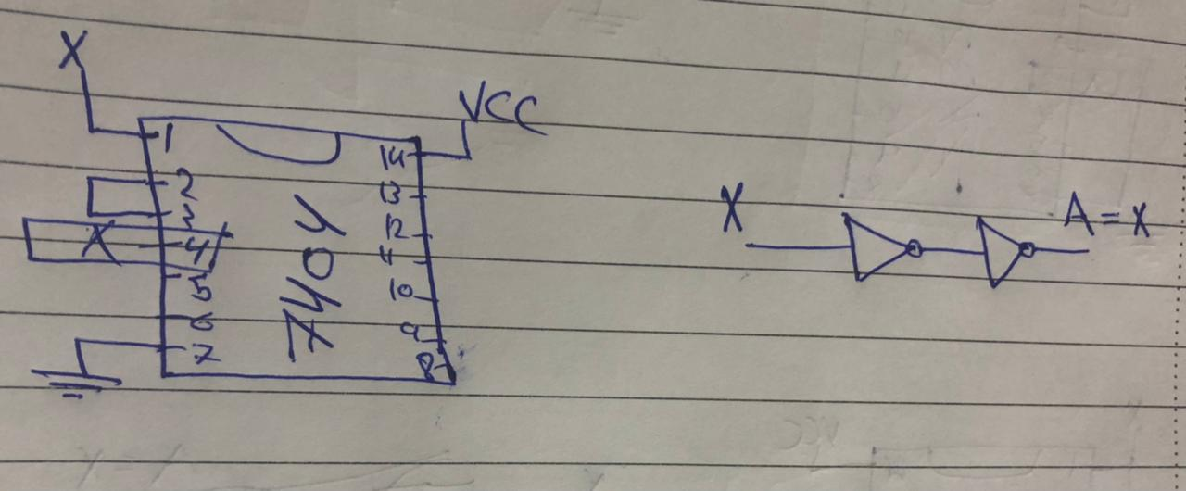

* (A + B)’ = A’ . B’

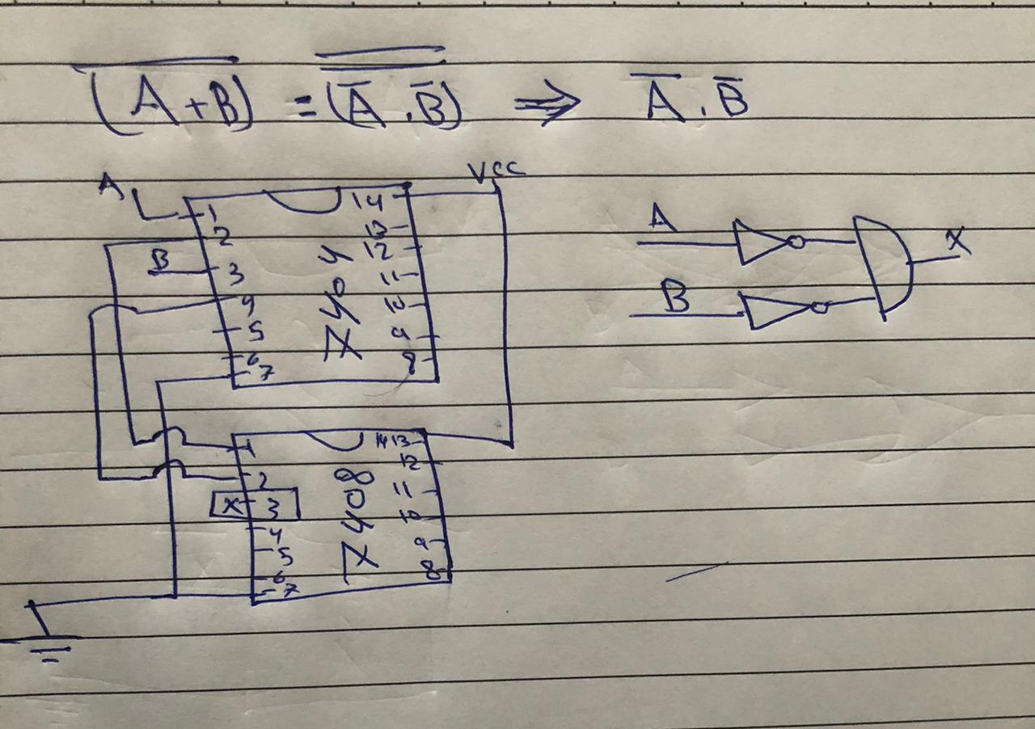

* (A . B)’ = A’ + B’

